Software Requirements Specification
for
Tutor Me
Version <1.0>

Prepared by
Group Name: <The Most Awesome Group Ever!!>
Jonathan Sullivan |  | jps3@email.uscupstate.edu
Rick Bennett |  | bennett.cpp@gmail.com
Kiran Lallu |  | lallu@email.uscupstate.edu
Ramie Barakat |  | barakatr@email.uscupstate.edu
Nicole Anderson |  | andersnf@email.uscupstate.edu

Instructor: | <Dr. Amanda Schwartz>
Course: | <Software student #>Engineering>
Lab Section: | <CSCI 540 Section 001>
Teaching Assistant: | <n/a>
Date: | <November 30, 2015>
Contents
Revisions ii
1 Introduction 1
1.1 Document Purpose 1
1.2 Product Scope 1
1.3 Intended Audience and Document Overview 1
1.4 Definitions, Acronyms and Abbreviations 1
1.5 Document Conventions 1
1.6 References and Acknowledgments 2
2 Overall Description 3
2.1 Product Perspective 3
2.2 Product Functionality 3
2.3 Users and Characteristics 3
2.4 Operating Environment 3
2.5 Design and Implementation Constraints 4
2.6 User Documentation 4
2.7 Assumptions and Dependencies 4
3 Specific Requirements 5
3.1 External Interface Requirements 5
3.2 Functional Requirements 6
3.3 Behaviour Requirements 6
4 Other Non-functional Requirements 7
4.1 Performance Requirements 7
4.2 Safety and Security Requirements 7
4.3 Software Quality Attributes 7
5 Other Requirements 8
Appendix A – Data Dictionary 9
Appendix B - Group Log 10

Revisions
Version | Primary Author(s) | Description of Version | Date Completed
Draft Type and Number | Full Name | Information about the revision. This table does not need to be filled in whenever a document is touched, only when the version is being upgraded. | 00/00/00

<In this template you will find text bounded by the “<>” symbols. This text appears in italics and is intended to guide you through the template and provide explanations regarding the different sections in this document. There are two types of comments in this document. These comments that are in black are intended specifically for that course. These comments that are in blue are more general and apply to any SRS. Please, make sure to delete all of the comments before submitting the document.

The explanations provided below, do not cover all of the material, but merely, the general nature of the information you would usually find in SRS documents. It is based on the IEEE requirements and was adapted specifically for the needs of Software Engineering 3K04/3M04 courses. Most of the sections in this template are required sections, i.e. you must include them in your version of the document. Failure to do so will result in marks deductions. Optional sections will be explicitly marked as optional.

Introduction
<TO DO: Please provide a brief introduction to your project and a brief overview of what the reader will find in this section.>

Document Purpose
This document is intended to define the functionality of a tutoring website. Specifically, this document includes an overall description, specific requirements, and any non-functional requirements.

Product Scope
This program is designed to aid teachers, tutors, and students in retrieving or logging any information needed regarding tutoring. Teachers can see who is getting tutored and what tutors are tutoring. Tutors can see who is signed in. Students can see what tutors are currently available and what they are currently tutoring. Benefits of this product include clearing the confusion of who is currently tutoring and for how long and what the tutor can and cannot tutor.

Intended Audience and Document Overview
This project is a new website for managing the tutor’s time and the students who received the tutoring. Its primary market is any university that has a tutoring lab available to help students excel in their classes and attain extra help that they may need. The website allows easy access to see who is tutoring, what subject the tutor can help with, and schedule appointments.

Overall Description

Product Perspective

Product Functionality
I. Every Page
1. The current available tutor.

II. Home Page
1. The location of the tutoring lab.
2. A picture of the tutoring lab.

III. Schedule Page
- A table containing the schedule for each individual tutor. This includes day, time, and tutor name.
- The ability to navigate to the tutor’s page by clicking on the tutor’s name.

IV. Tutors Page
1. A list of tutors with their name, a photo, and a short description.

V. Account Page
1. All Users
i. A menu containing the following options:
a. Profile – A page with the user’s name, the ability to add a photo, and a short description.
2. Teachers
i. A menu containing the following options:
a. Profile – A page containing all of the aforementioned capabilities under the menu for all users and the ability to add office hours.
b. Classes - A page containing a table for entering the classes a teacher is teaching.
c. Assignments – A page where teachers can upload assignments and notes for the tutor to view.
3. Tutors
i. A menu containing the following options:
a. Profile – A page containing all of the aforementioned capabilities under the menu for all users.
b. Classes – A page containing a table for entering the classes a tutor has taken.
c. Schedule – A page containing a table to manipulate their schedule.
d. Appointments – A page containing a table of appointments to be viewed by Tutors
      - A search function to sift through appointments by Student Name and/or Date.
e. Time log – A page containing a table for the Tutors to log their time. This includes an add button for adding a new time entry and delete button for deleting a time entry.
ii. Assignments Page – A page displaying the class, teacher, and assignment.
4. Students
i. A menu containing the following options:
a. Profile – A page containing all of the aforementioned capabilities under the menu for all users.
b. Classes – A page containing a table for entering the classes a student is currently taken.
c. Appointments – A page containing buttons that enable the students to schedule appointments with a specific tutor at a specific time and day.

VI. Log Page
- A table containing the following columns: Student Name, Time, Professor, and Class.
- A search bar that enables anyone to search through the log using any of the aforementioned columns (e.g. Student Name, Time, Professor, or Class).

Users and Characteristics
This program can be used by any university, which has a tutoring program. Specifically, this program is targeted towards teachers, tutors, and students.

Operating Environment
Our operating environment for this project is a platform that is web based. If time allows, we will have a platform for android app and iOS app.

Design and Implementation Constraints
<Describe any items or issues that will limit the options available to the developers. These might include: hardware limitations (timing requirements, memory requirements); interfaces to other applications; specific technologies, tools, and databases to be used; parallel operations; language requirements; communications protocols; security considerations; design conventions or programming standards (for example, if the customer’s organization will be responsible for maintaining the delivered software).
TO DO: In this section you need to consider all of the information you gathered so far, analyze it and correctly identify at least 5 constraints.>

User Documentation
<List the user documentation components (such as user manuals, on-line help, and tutorials) that will be delivered along with the software. Identify any known user documentation delivery formats or standards.
TO DO: You will not actually develop any user-manuals, but you need to describe what kind of manuals and what kind of help is needed for the software you will be developing. One paragraph should be sufficient for this section.>

Assumptions and Dependencies
<List any assumed factors (as opposed to known facts) that could affect the requirements stated in the SRS. These could include third-party or commercial components that you plan to use, issues around the development or operating environment, or constraints. The project could be affected if these assumptions are incorrect, are not shared, or change. Also identify any dependencies the project has on external factors, such as software components that you intend to reuse from another project.
TO DO: Provide a short list of some major assumptions that might significantly affect your design. For example, you can assume that your client will have 1, 2 or at most 50 Automated Banking Machines. Every number has a significant effect on the design of your system. >

Specific Requirements

External Interface Requirements

User Interfaces
- Navigation Bar
Toolbar on top of the page

- Unsigned-In – Starting From the far left
- Graduation hat, followed by text saying TutorMe, When clicked, user is brought to the home page.
- Graph Icon, followed by text saying Log. When clicked, user is brought to the Log page
- Small calendar icon, followed by text saying Schedule. When clicked, user is brought to the Schedule page.
- A person icon, followed by text saying Tutors. When clicked, user is brought to the Tutors page.
- Pulled to the right, a box with text says “Available Tutor:”, if a tutor is checked in, the box will be green and will have the tutors name listed, and if a tutor is not checked in, the box will be read and will say N/A.
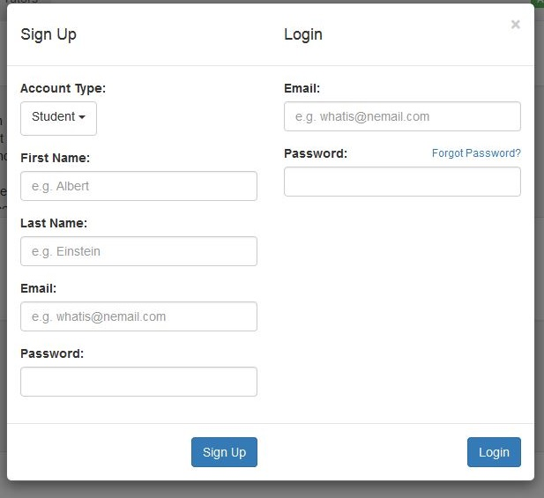

- To the right of this (making it the far right), there is a blue button with text saying “Login or Sign Up”. When clicked a modal will appear, and graying out the rest of the site.
On the left side of the modal there is the sign up option. Starting from the top, there is text saying “Sign Up” in the heading. Below the heading text saying “Account Type:”, followed by a drop box with the options: Student, Teacher, and Tutor. Below this is a list of text saying “First Name:”, “Last Name:”, “Email”, and “Password:”, Followed by each of these text is a box to enter said value. Finally below the last textbox attribute is a blue button that says “Sign Up”. When this button is clicked, a new user is made.
On the right side of the modal this is a Log in option. Starting from the top, there is text saying “Log In” in the heading. Followed by text saying “Email:”, below this is a box to enter the email into. Then, text saying “Password:”, followed by a box toe enter the password into. Finally, below there is a blue button that says “Sign In”. When this button is clicked, the user is now signed in but is still left on the Homepage.
In the top right corner of the modal is an ‘x’ to close the modal.

- Signed-In
Just like before but there are two differences:
- Instead of the sign-up/login button there is now a box button with an icon that had 4 small boxes. When clicked, a drop down menu appears, with the options of Account, Check In, and Logout. When Account is clicked, a user is directed to their account page. When Check In is clicked, the user is now “checked in”, meaning for students, they are added to the log, and for tutors, their name will appear in the tutor Availability.
- This is for tutors only. On the navigation bar, to the right of tutors an Assignments option appears. When clicked, the tutor is taken to the Assignments page.

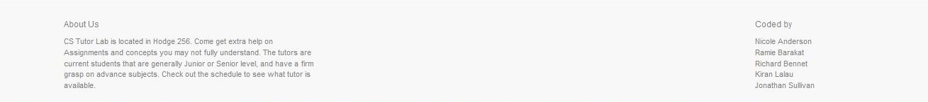

- Footer
The Footer appears on the bottom of the screen for every page, but the account page. Far left is an “About Us” paragraph. On the far right is a list of the website creators.

- Home Page

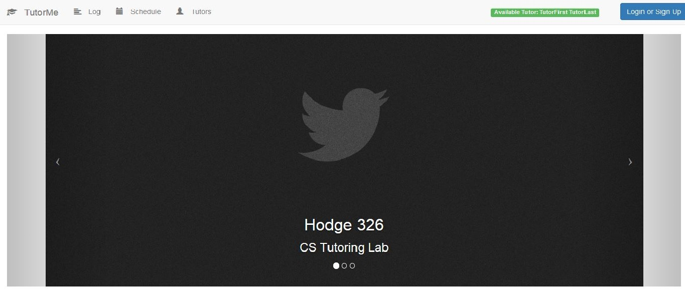

- Carousel
The Carousel holds three slides with arrows on each side of the picture, if either are clicked, the, the user is taken to the next slide. The Carousel does work alone as well, sitting on one slide for a few seconds at a time. On the bottom of each slide there may be text, but not always. At the very bottom of the slides is three little circles that indicate which slide you’re on (i.e. if you’re on the first slide, the first bubble is filled in). On the left and right side of slides is gray fade in.

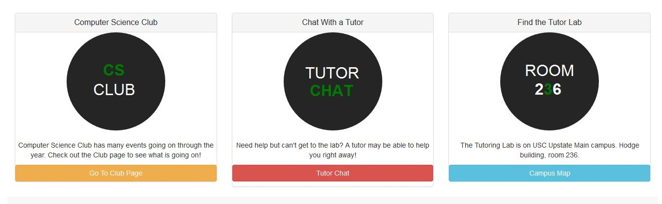
- Panels
Below the Carousel is three panels, all equal in size, located right next to each other. From left to right:
- Computer Science Club panel-
- Chat with a Tutor panel-
- Find the tutor Lab panel-

- Log Page

- Schedule Page

- Tutors Page

- Assignments Page(only when tutors are signed in)

Tutors can access this page by clicking on the assignments link located on the navigation bar. Tutors can view and download the assignments as well as the comments made by the teacher.
There will be a page that will have all the current assignments that teachers have uploaded. There will be a folder icon, assignment name, teacher, and class. On this page, there will be a collection view of collection view sells containing an image representing the assignment. Below the image representing the assignment, there will be 3 labels. The first label will be the name of the assignment. The second label will be the teacher’s name. The third label will be the class name. Once an assignment is clicked on, it will navigate to a different page that will list the teacher’s comments in the middle of the page. Below this, there will be a download button to download the assignment.

- Account Page

Once a user is on their account page, there is a menu on the far left that will have the following options (depending on type of account). The Options are stacked on top of each other.

- Profile (All users)

Once the profile option is selected, below the navigation bar, and to the right of the Account Menu these attributes will appear: A 64 x 64 picture icon (that can be changed by user, through an edit option, explained later). To the right of the picture icon, First and Last name of the user is listed. Below the name, the type of account is listed (i.e. Teacher). Below this is a blue button that says edit. Below this is a well that stores the users description (If a tutor, this is saved and is added to the Tutor page from the Navigation Bar). If the edit button is clicked, the button text will say save and, the user can edit the description in the well and push save.

- Appointments (Students and Tutors)

- Student’s Appointment:
Students will be able to view, add, reschedule, and cancel appointments. The Student’s Appointment page will list current appointments in a table. At the top of the current appointment’s table, there will be a label that says appointments and an ADD button on the top right hand side. Beside each current appointment in the table, there will be an X button to delete that appointment. After pushing the ADD button, a pop box will appear in the middle of the page. At the top of the pop up box, there will be a label stating ‘Add Appointment.’ This pop up box will display a calendar button for selecting a date. Next, we will have a drop down box containing available times. Finally, we will have a drop down box containing the tutor’s name that is available for that specific date and time already selected from above. At the very bottom of the pop up box, there will be 2 buttons side by side: one for cancel and one for submit. Cancel will close out the pop up box and Submit will schedule an appointment.

- Tutor’s Appointment:
The tutor will be able to view appointments in a table. There will a label on the top of the table that says Appointments. Underneath the label, all the appointments that the tutor will have will be displayed in order by time.

- Assignments (Teacher only)

Teachers can browse for the file, view current and past assignments, and make comments on those assignments. At the top of the teacher’s assignment table, there will be a label that says assignments and an ADD button on the top right hand side. Beside each current assignment in the table, there will be an X button to delete that assignment. After pushing the ADD button, a pop box will appear in the middle of the page. In the top center of the page, there will be a label that says Browse and a box beside the label with a button at the end of the box to attach a file. Once file is attached, the name will appear within the box. Next, there will be a label for comments below the Browse label. Beside the comments label, there will be a box for teachers to write comments about the assignment. At the very bottom of the pop-up box, there will be 2 buttons side by side: one for cancel and one for submit. Cancel will close out the pop-up box and Submit will upload the assignment.

- Classes

Hardware Interfaces
Tutor Me is a web-based database system. Therefore any device with an internet connection and appropriate input device such as a keyboard are required.

Software Interfaces
PHP will be used to allow the developers to follow the DRY rule, Don’t Repeat Yourself. For example, the HTML code for a navigation bar will be of better use in its own PHP file. This allows the developer to use PHP to include the file in the HTML file instead of copying and pasting the navigation bar code in to every HTML file it is needed. This will also reduce bugs.

Javascript will be used to add actions to HTML pages and delegate responsibilities. For example, if a user taps on a button in the HTML page the corresponding Javascript view will call the corresponding method. This is also known as delegation or operation of duties. Combining HTML and Javascript in this way will make the code more robust, scalable, and easier to maintain.

HTML5 will be used to design the website’s appearance. HTML5 also eliminates the need for third party extensions such as adobe flash.

CSS3 will be used to layout the website’s elements. This enables the website to have the same layout across multiple resolutions, and ultimately, multiple devices.

Bootstrap will be used in conjunction with CSS3 to design the website using pre-made classes. This allows the developers to cut down on the time needed to design and develop the website. By using the pre-made classes provided by bootstrap the developers will be able to focus more on the business logic needed to make the program run correctly and focus less on the intricacies of making the program look correct.

Parse will be used as the database for the website and other various features such as Push Notifications. Parse also allows us to move a vast amount of code to the server and thus reducing the amount of work needed to be down on the client side. Parse also enables the developers to work with a central server to access the data on any platform including Web, iOS, and Android.

The Parse Javascript SDK will be used to interface with the database and any other Parse services that may be taken advantage of such as, Push Notifications or Cloud Code. If time permits, the Parse iOS SDK and Parse Android SDK will be used for the same functions as mentioned above, but used on their corresponding platforms.

Backbone.js will be used to aid developers in building modular code. For this project the developers will be using the common design pattern MVC. MVC stands for Model, View, Controller. The model will be used for business logic and the view will be used for responding to actions. Unfortunately, Backbone.js does not provide a true MVC design pattern meaning there is not a controller object to inherit from. In this particular case the view will also act as a controller.

If time permits, the developers will also use Objective-C or Swift for the iOS application development and Java/XML for the Android application development.

Communications Interfaces
Tutor Me will be linked to a database using Parse that will generate appointments and assignment documents.

Functional Requirements
I. Every Page
1. The current available tutor.

II. Home Page
1. The location of the tutoring lab.
2. A picture of the tutoring lab.

III. Schedule Page
- A table containing the schedule for each individual tutor. This includes day, time, and tutor name.
- The ability to navigate to the tutor’s page by clicking on the tutor’s name.

IV. Tutors Page
1. A list of tutors with their name, a photo, and a short description.

V. Account Page
1. All Users
i. A menu containing the following options:
a. Profile – A page with the user’s name, the ability to add a photo, and a short description.
2. Teachers
i. A menu containing the following options:
a. Profile – A page containing all of the aforementioned capabilities under the menu for all users and the ability to add office hours.
b. Classes - A page containing a table for entering the classes a teacher is teaching.
c. Assignments – A page where teachers can upload assignments and notes for the tutor to view. These assignments will be stored and retrieved from the Parse Database using the Parse Javascript SDK.
3. Tutors
i. A menu containing the following options:
a. Profile – A page containing all of the aforementioned capabilities under the menu for all users.
b. Classes – A page containing a table for entering the classes a tutor has taken.
c. Schedule – A page containing a table to manipulate their schedule.
d. Appointments – A page containing a table of appointments to be viewed by tutors. These appointments will be stored and retrieved from the Parse Database using the Parse Javascript SDK.
e. Time log – A page containing a table for the Tutors to log their time. This includes an add button for adding a new time entry and delete button for deleting a time entry.
4. Students
i. A menu containing the following options:
a. Profile – A page containing all of the aforementioned capabilities under the menu for all users.
b. Classes – A page containing a table for entering the classes a student is currently taken.
c. Appointments – A page containing buttons that enable the students to schedule appointments with a specific tutor at a specific time and day.

VI. Log Page
- A table containing the following columns: Student Name, Time, Professor, and Class.
- A search bar that enables anyone to search through the log using any of the aforementioned columns (e.g. Student Name, Time, Professor, or Class).
.

Behaviour Requirements

Use Case View
<A use case defines a goal-oriented set of interactions between external actors and the system under consideration. Since sometimes we will not be able to specify completely the behaviour of the system by just State Diagrams, we use use-cases to complete what we have already started in section 3.3.1.

TO DO: Provide a use case diagram which will encapsulate the entire system and all possible actors. Do not include detailed use case descriptions (these will be needed when you will be working on the Test Plan), but make sure to include a short description of what every use-case is, who are the actors in your diagram. For more information please refer to your UML guide and the MiniThermostat SRS example file.>

Other Non-functional Requirements

Performance Requirements
<If there are performance requirements for the product under various circumstances, state them here and explain their rationale, to help the developers understand the intent and make suitable design choices. Specify the timing relationships for real time systems. Make such requirements as specific as possible. You may need to state performance requirements for individual functional requirements or features.
TODO: Provide at least 5 different performance requirements based on the information you collected from the client. For example you can say “1. Any transaction will not take more than 10 seconds, etc…>

Safety and Security Requirements
<Specify those requirements that are concerned with possible loss, damage, or harm that could result from the use of the product. Define any safeguards or actions that must be taken, as well as actions that must be prevented. Refer to any external policies or regulations that state safety issues that affect the product’s design or use. Define any safety certifications that must be satisfied. Specify any requirements regarding security or privacy issues surrounding use of the product or protection of the data used or created by the product. Define any user identity authentication requirements.
TODO:
- Provide at least 3 different safety requirements based on your interview with the client or, on your ABM related research, and again you need to be creative here.
- Describe briefly what level of security is expected from this product by your client and provide a bulleted (or numbered) list of the major security requirements.>

Software Quality Attributes
<Specify any additional quality characteristics for the product that will be important to either the customers or the developers. Some to consider are: adaptability, availability, correctness, flexibility, interoperability, maintainability, portability, reliability, reusability, robustness, testability, and usability. Write these to be specific, quantitative, and verifiable when possible. At the least, clarify the relative preferences for various attributes, such as ease of use over ease of learning.

TODO: Use subsections (e.g., 4.3.1 Reliability, 4.3.2 Portability, etc…) provide requirements related to the different software quality attributes. Base the information you include in these subsections on the material you have learned in the class. Make sure, that you do not just write “This software shall be maintainable…” Indicate how you plan to achieve it, & etc…Do not forget to include such attributes as the design for change. Please note that you need to include at least 2 quality attributes, but it is the mere minimum and it will not receive the full marks.>

Other Requirements
<This section is Optional. Define any other requirements not covered elsewhere in the SRS. This might include database requirements, internationalization requirements, legal requirements, reuse objectives for the project, and so on. Add any new sections that are pertinent to the project.>

Appendix A – Data Dictionary

<Data dictionary is used to track all the different variables, states and functional requirements that you described in your document. Make sure to include the complete list of all constants, state variables (and their possible states), inputs and outputs in a table. In the table, include the description of these items as well as all related operations and requirements.>

Appendix B - Group Log
<Please include here all the minutes from your group meetings, your group activities, and any other relevant information that will assist the Teaching Assistant to determine the effort put forth to produce this document>

